Network Design Proposal
Network Design Proposal

Prepared for:
University of Maryland University College

Prepared by:
Student Name

I. Network Design

A. Network Topology

Technical Requirements

In this space, the network topology exhibits the course of the physical arrange usage and represents the $64000 functions of the system design, which includes the gadgets, areas, and link institution.
In the two server rooms of the structure, the centralized server and therefore the servers are founded. The centralized pc interfaces with the servers. The oversaw changes from the distinctive floors at that time keep company with the centralized server.
The physical style has the subsequent features:
• The building is outfitted with class 6e cabling and divider plates within the workplaces, study halls, labs, etc.
• There are Cat half-dozen cabling and divider plates fitted within the lecture rooms, library and therefore the workplaces
• at intervals the structure, oversaw switches are used. Overseen switches provide a lot of power over local area network traffic and offer propelled highlights to manage that traffic. It offers the capability to rearrange, oversee, and screen local area network and this offers a lot of distinguished power over however data goes over the system and UN agency approaches it. Also, oversaw switches use conventions, as an example, the straightforward Network Management Protocol, or what we have a tendency to decision SNMP, for checking the gadgets on the system. SNMP may be a convention that encourages the commerce of the executives’ information between system gadgets. SNMP queries will decide the soundness of the system or the standing of a selected widget. By showing this data in associate degree effectively gotten arrangement, IT administrators set at a focal web site will screen the execution of the system and speedily acknowledge and fix organize problems while not having to physically collaborate with the switch.
• A separate switch is used within the different floor. Thus the only |the only real} reason for this switch is to handle the VLAN of the varsity so on keep the understudies from progressing to the essential information of the, as an example, authoritative information.
• The ISP represents net Service supplier. These are organizations that provide access to the net.
• The firewall may be a widget supposed to permit or deny organize transmissions addicted to plenty of tenets and is each currently and once more accustomed protect systems from unapproved get to whereas permitting real correspondences to pass.
Proposed Topology

A star topology is a topology for a Local Area Network (LAN) in which all hubs are independently associated with a focal association point, similar to a center or a switch. A star takes more link than for example a transport, however the advantage is that if a link flops, just a single hub will be cut down.
In this setup, each hub interfaces with a focal system gadget, similar to a center, switch, or PC. The focal system gadget goes about as a server and the fringe gadgets go about as customers. Contingent upon the sort of system card utilized in every PC of the star topology, a coaxial link or a RJ-45 organize link is utilized to interface PCs together.
Advantages of star topology
- Centralized the board of the system, using the focal PC, center, or switch.
- Easy to add another PC to the system.
- If one PC on the system falls flat, the remainder of the system keeps on working regularly.
Disadvantages of star topology
- May have a greater expense to actualize, particularly when utilizing a switch or switch as the focal system gadget.
- The focal system gadget decides the execution and number of hubs the system can deal with.
- If the focal PC, center point, or switch fizzles, the whole system goes down and all PCs are separated from the system.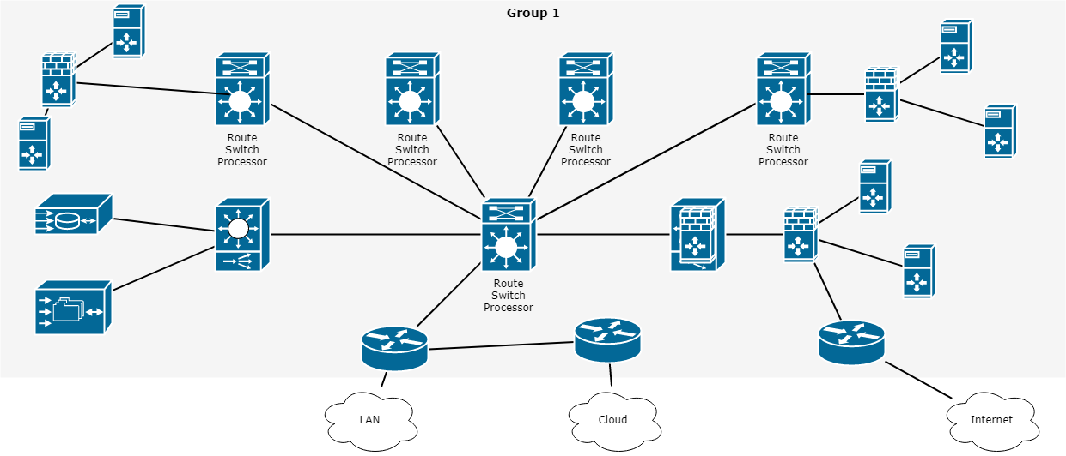

Justification

Star topology is a network topology where every individual bit of a system is connected to a focal hub (frequently called a center point or switch). The connection of these system pieces to the focal segment is outwardly spoken to in a structure like a star. All traffic radiates from the center of the star. The focal site is responsible for every one of the hubs joined to it. The focal center point is typically a quick, independent PC and is in charge of steering all traffic to different hubs. The primary preferences of a star arrange is that one failing hub does not influence the remainder of the system. In any case, this kind of system can be inclined to bottleneck and disappointment issues at the focal site.

B. Cables and Connectors

Technical Requirements

Cat 6 links or to give them their full name class 6 link is the current favored link type for LAN system and phone wiring where curved pair cabling is required. Cat 6 links comprise of an unshielded link containing four contorted sets, regularly of 24 check wire. The ending connector is a RJ-45 jack. In perspective on this these Cat5 organize links are regularly alluded to as RJ45 arrange links or RJ45 fix links. Ensured Cat-6 links will have the wording "Cat 6" composed as an afterthought. As they adjust to EIA/TIA 568A-5, this is composed on the external sheath. It is in every case best to utilize the suitable system links when setting up a system as flawed or not to standard links can cause issues that might be hard to recognize and follow.
Cat 6 arrange link is currently the standard type of wound pair link and overrides Cat 3. The Cat 6 links can be utilized for information accelerates to 125 Mbps, in this way empowering them to help 100Base-T which has a most extreme information speed of 100 Mbps while the Cat-3 link was intended to be good with 10Base-T. The Cat6 link can bolster working up to lengths of 100 meters at the full information rate.
Where it is important to work at higher rates, as on account of Gigabit Ethernet, an upgraded rendition of Cat 6 link known as Cat 6e is frequently suggested, in spite of the fact that Cat 6 is determined to work with Gigabit Ethernet, 1000Base-T. On the other hand Cat 6e can be utilized with 100Base-T to empower more noteworthy lengths (up to 350 meters) to be accomplished.
Proposed Cables and Connectors

Unshielded Twisted Pair (UTP) - This is the most mainstream type of links in the system and the least expensive structure that you can run with. The UTP has four sets of wires and all inside plastic sheathing. The main motivation that we call it Twisted Pair is to shield the wires from obstruction from themselves. Each wire is just ensured with a dainty plastic sheath.
There are seven unique sorts of UTP classifications and, contingent upon what you need to accomplish, you would require the fitting kind of link. UTP-CAT6e is the most prevalent UTP link which came to supplant the old coaxial link that was not ready to stay aware of the steady developing requirement for quicker and progressively dependable systems.

Justification

The attributes of UTP are exceptionally great and make it simple to work with, introduce, grow and investigate and we are going to take a gander at the diverse wiring plans accessible for UTP, how to make a straight through UTP link, rules for safe activity and a ton of other cool stuff.
C. Networking and Internetworking Hardware

Technical Requirements

An internetworking gadget is a generally utilized term for any equipment inside systems that interface diverse system assets. Key gadgets that involve a system are switches, scaffolds, repeaters and portals. All gadgets have independently introduced extension highlights, per arrange prerequisites and situations.
Proposed Networking and Internetworking Devices
Network Hub: Network Hub is a systems administration gadget which is utilized to interface different system has. A system center point is likewise used to do information exchange. The information is moved as far as bundles on a PC arrange. Along these lines, when a host sends an information parcel to a system center point, the center duplicates the information bundle to the majority of its ports associated with. Like this, every one of the ports think about the information and the port for whom the bundle is planned, claims the parcel.

Network Switch: Like a center point, a switch likewise works at the layer of LAN (Local Area Network) yet you can say that a switch is more insightful than a center. While center point simply takes every necessary step of information sending, a switch does 'channel and sending' which is an increasingly insightful method for managing the information parcels.

Modem: A Modem is to some degree all the more intriguing system gadget in our day by day life. So, in the event that you have seen around, you get a web association through a wire (there are distinctive sorts of wires) to your home. This wire is utilized to convey our web information outside to the web world.

Network Router: A switch is a system gadget which is in charge of directing traffic starting with one then onto the next system. These two systems could be a privately-owned business system to an open system. You can think about a switch as a traffic police who guides diverse system traffic to various bearings.

Bridge: If a switch associates two unique sorts of systems, at that point a scaffold interfaces two subnetworks as a piece of a similar system. You can consider two distinct labs or two unique floors associated by an extension.

Repeater: A repeater is an electronic gadget that enhances the flag it gets. In different terms, you can consider repeater a gadget which gets a flag and retransmits it at a more elevated amount or higher power with the goal that the flag can cover longer separations.

Justification
Switches are very keen system gadgets that are basically utilized for huge systems and give the best information way to viable correspondence. Switches have memory chips which store extensive amounts of system addresses.
Extensions are utilized to interface two substantial systems by giving distinctive system administrations.
Repeaters are utilized for flag and information recovery and are basically in charge of information enhancement.
Passages are internetworking gadgets used to change over arrangements and are the foundation of any system design.

D. Wide Area Network (WAN) Design

Technical Requirements

In this section, you'll assess UMUC’s technical needs associated with the Wide space Network (WAN) style. you'll must build assumptions wherever applicable. once creating assumptions, list every and confirm to justify the answer within the Justification section.

Proposed Wide Area Network (WAN) Design

A Wide Area Network (WAN) is a PC organize covering numerous separation regions, which may spread over the whole world. WANs regularly interface different littler systems, for example, neighborhood (LANs) or metro region systems (MANs). The world's most mainstream WAN is the Internet. A few sections of the Internet are likewise WANs in themselves. The key contrast among WAN and LAN advances is versatility. C WAN must most likely develop as expected to cover different urban communities, even nations and mainlands.

A lot of switches and switches are interconnected to shape a Wide Area Network. The switches can be associated in various topologies, for example, full work and half work. A wide territory system might be exclusive or leased from a specialist organization, yet the term generally implies the consideration of open (shared client) systems.
Both parcel exchanging and circuit exchanging innovations are utilized in the WAN. Bundle changing enables clients to share normal bearer assets with the goal that the transporter can make increasingly effective utilization of its framework. In a parcel exchanging setup, systems have associations into the bearer's system, and numerous clients share the transporter's system. The transporter would then be able to make virtual circuits between clients' destinations by which parcels of information are conveyed from one to the next through the system.
Circuit Switching enables information associations with be built up when required and after that ended when correspondence is finished. This works like a typical phone line works for voice correspondence. Incorporated Services Digital Network (ISDN) is a genuine case of circuit exchanging. At the point when a switch has information for a remote site, the exchanged circuit is started with the circuit number of the remote system.

Justification

This section ought to be accustomed justify your planned answer supported the technical needs and assumptions.

E. Computer Systems Hardware

Technical Requirements

In this section, you may assess UMUC’s technical needs associated with the pc systems hardware for each room finish points and servers likewise as what would be required for dedicated IT use. you may have to create assumptions wherever acceptable. once creating assumptions, list every and confirm to justify the answer within the Justification section.

Proposed Computer Systems Hardware

Gadgets and media are the physical elements, or instrumentation, of the system. instrumentation contains the components of the system stage that normally are clear, for instance, a PC, PC, switch, switch, remote passage, or the cabling wont to associate the gadgets. Incidentally, some system components might not be obvious. On account of remote media, as an example, messages are transmitted through the air utilizing indiscernible radio return or infrared waves.

System components are utilised to present administrations and procedures. These administrations and procedures are the correspondence programs, known as programming, that keep running on the organized gadgets. A system administration offers knowledge thanks to a solicitation. Administrations incorporate an outsized variety of the regular system applications people utilize daily, almost like email facilitating administrations and internet facilitating administrations. Procedures provide the utility that coordinates and moves the messages through the system. Procedures are additional delicate to United States of America nevertheless are basic to the activity of systems.
Justification

This section ought to be accustomed justify your projected answer supported the technical needs and assumptions.

II. Network Addressing and Security

A. Subnetting

Overview

Subnetting may be a method of breaking an outsized network into tiny networks referred to as subnets. Subnetting happens once we extend the default boundary of the subnet mask. Basically, we tend to borrow host bits to make networks (i.e., subnets).

We have been assigned the network address 192.168.22.0. supported the chart below, we all know this can be a category C address. this can be determined by perceptive the primary octet of the science address, that is 192. This octet falls in between 192 and 223.

Class | Octet Decimal Range
A | 1 - 126
B | 128 - 191
C | 192 - 223

Each class has a predefined default subnet mask that tells us the octets, which are already part of the network portion, as well as how many bits we have available to work with.

Class | Subnet Mask | Format
A | 255.0.0.0 | Network.Host.Host.Host
B | 255.255.0.0 | Network.Network.Host.Host
C | 255.255.255.0 | Network.Network.Network.Host

CIDR (Classless Inter Domain Routing)

●CIDR could be a slash notation of the subnet mask. CIDR tells U.S.A. the quantity of on bits during a network address.
● category A has default subnet mask 255.0.0.0. which means initial octet of the subnet mask has all on bits. In slash notation, it might be written as /8, means that address has eight bits on.
● category B has default subnet mask 255.255.0.0. which means initial 2 octets of the subnet mask have all on bits. In slash notation, it might be written as /16, means that address has sixteen bits on.
● category C has default subnet mask 255.255.255.0. which means initial 3 octets of the subnet mask have all on bits. In slash notation, it might be written as /24, means that address has twenty four bits on.

Technical Requirements

UMUC has not determined however they'll use all of the physical area inside the fresh chartered building, however the diagrams below convey the planned finish state. However, they need determined to use a number of the area within the short term. In doing thus, we'll proceed with the planned arrange. Initially, the building can house 5 classrooms, 1 student computer lab, 1 library, and 1 office.

- ● within the below building diagrams, we are going to use workplace five (Admissions) on the primary floor. every workplace can have one laptop for workers use, with the exception of the admissions workplace, which is able to have five computers. supported the subnetting performed higher than, we tend to is also ready to add additional devices within the future.

- ● the lecture rooms are labelled room #1, room #2, and room #4 on the primary floor and room #1 and room #5 on the second floor; every classroom can have a closet. every room can have twenty five devices: twenty three student computers, one educator laptop, and one server within the closet, for educational use.

- ● Students ought to take into account high traffic areas for Wi-Fi, like the sitting areas and not the lecture rooms. The Wi-Fi network ought to be white from the wired network and enforced on a separate category C network. what is going to the network address, range, and broadcast address for this separate category C wireless address be?

- ● additionally, there'll be a student laptop science laboratory which will offer computer access to students to try and do their schoolwork. the scholar laptop science laboratory is found on the second floor. there'll be twenty four computers during this science laboratory and one server within the closet.
- to permit students access to library resources, the library will have ten computers for the final public to use and five computers for library workers.
- there'll be 2 server rooms, one on the primary floor and one on the second floor.

To be clear, the diagram below conveys the proposed end state.

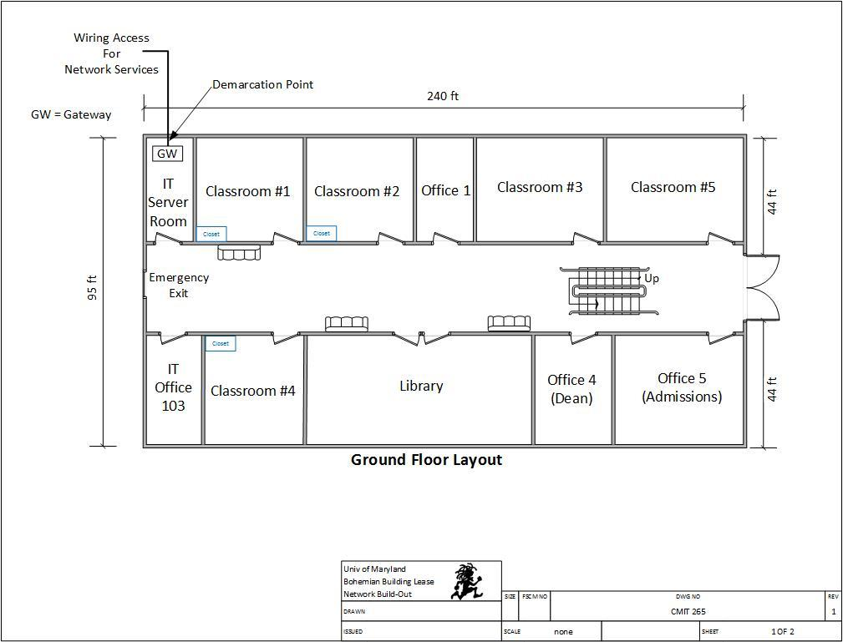

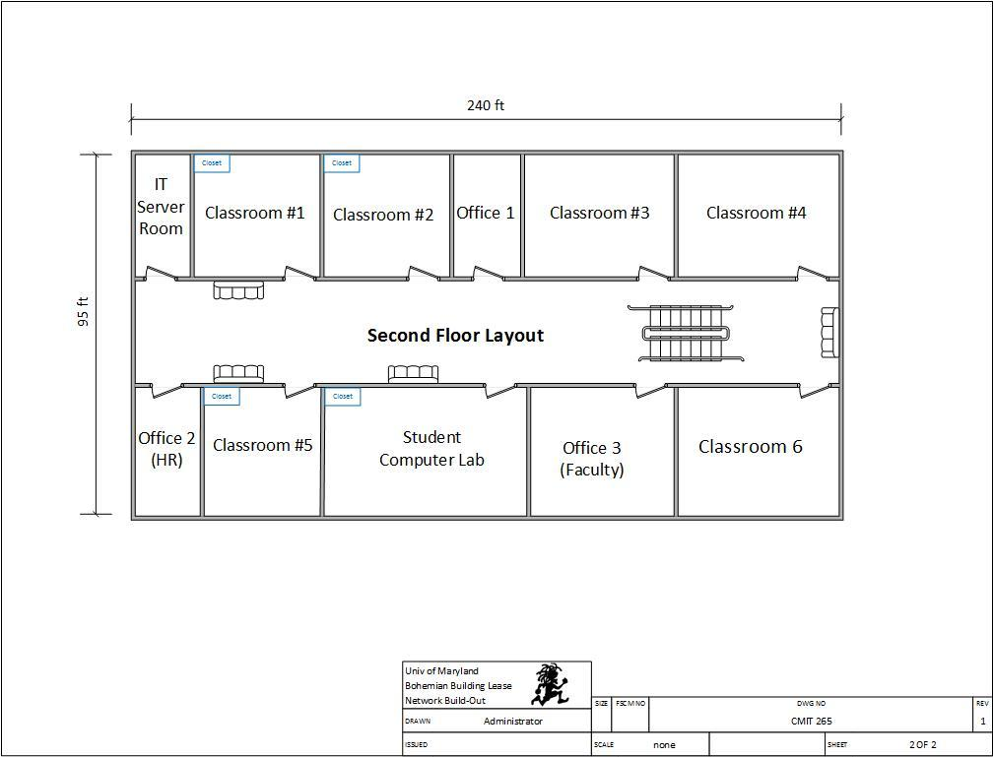

Given the same situation, we have a tendency to are visiting use the 192.168.3.0 network and build a complete of eight subnets, with twenty-five potential hosts on every subnet. The chart below describes structures the situation to incorporate every subnet and needed hosts.
Subnet Description | Required Hosts
Classroom 1 (First Floor) | 25 Computers
Classroom 2 (First Floor) | 25 Computers
Classroom 4 (First Floor) | 25 Computers
Classroom 1 (Second Floor) | 25 Computers
Classroom 5 (Second Floor) | 25 Computers
Office 5 – Admissions (Second Floor) | 25 Computers
Student Computer Lab | 25 Computers
Library | 15 Computers
Note: Using the How to Subnet a Network Video provided in CMIT 265 LEO - Content - UMUC Network Design Proposal, complete the following chart.

Proposed Subnet
Subnet | Network Address | Host Address Range | Broadcast Address
Subnet Mask: 255.255.255. ___
Classroom 1 (First Floor) | 192.168.22.0 | 192.168.22.1 - 192.168.22.30 | 192.168.22.31
Classroom 2 (First Floor) | 192.168.22.32 | 192.168.22.33 - 192.168.22.62 | 192.168.22.63
Classroom 4 (First Floor) | 192.168.22.64 | 192.168.22.65 - 192.168.22.94 | 192.168.22.95
Classroom 1 (Second Floor) | 192.168.22.96 | 192.168.22.97 - 192.168.22.126 | 192.168.22.127
Classroom 5 (Second Floor) | 192.168.22.128 | 192.168.22.129 - 192.168.22.158 | 192.168.22.159
Office 5 – Admissions (Second Floor) | 192.168.22.160 | 192.168.22.161 - 192.168.22.190 | 192.168.22.191
Student Computer Lab | 192.168.22.192 | 192.168.22.193 - 192.168.22.222 | 192.168.22.223
Library | 192.168.22.224 | 192.168.22.225- 192.168.22.254 | 192.168.22.255
Wi-Fi Network | 192.168.22.0 | 192.168.22.1 – 192.168.22.254 | 192.168.22.255
B. Firewall Implementation

Technical Requirements

In this section, you'll assess UMUC’s technical needs associated with the firewall implementation. you'll must build assumptions wherever acceptable. once creating assumptions, list every and confirm to justify the answer within the Justification section.
Proposed Firewall Implementation

Packet filtering firewall: On the net, bundle separation is that the approach toward passing or interference parcels at a system interface addicted to supply and goal locations, ports, or conventions. The procedure is employed associated with bundle devastation and Network Address Translation (NAT). Bundle separation is often a part of a firewall program for shielding a locality organize from undesirable interruption.

In a product firewall, parcel separation is finished by a program known as a bundle channel. The parcel channel appearance at the header of each bundle addicted to a specific arrangement of pointers, and on it premise, chooses to stay it from passing (called DROP) or alter it to pass (called ACCEPT).

Justification

This section ought to be accustomed justify your projected resolution supported the technical necessities and assumptions.

C. Intrusion Detection System / Intrusion Protection System

Technical Requirements

In this section, you'll assess UMUC’s technical necessities associated with the intrusion detection system (IDS) and Intrusion bar System (IPS). you'll have to create assumptions wherever acceptable. once creating assumptions, list every and ensure to justify the answer within the Justification section.

Proposed Intrusion Detection System / Intrusion Protection System

An IDS screens organize traffic searching down suspicious movement and notable dangers, causation up cautions once it finds such things. A semipermanent company digital security staple, interruption identification as a capability stays basic within the advanced venture, however maybe not as associate freelance arrangement.

Interruption recognition programming frameworks will be broken into 2 general classifications: have primarily based and organize based; those two classifications address wherever sensors for the IDS are place (on a host/endpoint or on a system).

Interruption identification is associate inactive innovation; it acknowledges and recognizes a problem however go in the stream of system traffic, Novak said. "As documented, the planning is to get and alarm on imperative traffic. associate alarm educates the IDS examiner that some intriguing traffic has been watched. Be that because it could, it's someday presently the grounds that the traffic isn't blocked or ceased in any capability from achieving its goal."

Contrast that with firewalls that shut notable malware and interruption compensative action framework (IPS) innovation, that because the name portrays, to boot squares vindictive traffic.

Despite the actual fact that associate IDS doesn't stop malware, cybersecurity specialists aforementioned the innovation still incorporates a spot within the leading edge venture.

"The quality of what it will continues to be primarily important," aforementioned Eric Hanselman, boss investigator with 451 analysis. "The IDS piece itself is thus far pertinent in light-weight of the actual fact that at its center it's characteristic a functioning assault.”

Justification

This section ought to be accustomed justify your projected resolution supported the technical necessities and assumptions.

D. DMZ Implementation

Technical Requirements

In this section, you'll assess UMUC’s technical necessities associated with the demilitarized zone implementation. you'll must create assumptions wherever applicable. once creating assumptions, list every and ensure to justify the answer within the Justification section.

Proposed DMZ Implementation

This section ought to be accustomed offer the main points of your planned answer, supported the technical needs and assumptions. What uses would UMUC want for a DMZ? What instrumentation ought to be placed into the DMZ? Student should be specific once discussing the models, types, and costs.

Justification

This section ought to be accustomed justify your projected resolution supported the technical necessities and assumptions.

E. Physical Security Measures

Technical Requirements

In this section, you may assess UMUC’s technical necessities associated with the physical security measures. you may have to create assumptions wherever acceptable. once creating assumptions, list every and ensure to justify the answer within the Justification section.

Proposed Physical Security Measures

#1: Lock up the server room: so, even before you lock down the servers, truth be told, before you even flip them on out of the blue, you must guarantee that there are nice bolts on the server area access. Obviously, the simplest lock on the earth will an entire ton of nothing within the event that it isn't used, therefore you likewise want methods necessitating that those entryways be fast whenever the area is empty, and therefore the arrangements ought to started United Nations agency has the key or keycode to induce in.

The server area is that the core of your physical system, and someone with physical access to the servers, switches, switches, links and totally different gadgets therein area will do large hurt.

#2: founded surveillance: protection the door to the server area could be a smart opening, however somebody may break in, or somebody United Nations agency has licensed access may misuse that authority. you wish the simplest way to understand United Nations agency goes in and out and once. A log book for language in and out is that the most elemental thanks to accomplish this, however it's lots of drawbacks. an individual with malicious intent is probably going to simply bypass it.

A video police investigation camera, placed during a location that produces it troublesome to tamper with or disable (or even to find) however offers an honest read of persons coming into and deed ought to supplement the log book or electronic access system. police investigation cams will monitor unendingly, or they'll use motion detection technology to record only if somebody is moving concerning. they'll even be founded to send e-mail or cellular phone notification if motion is detected once it shouldn't be (such as once hours).

#3: confirm the foremost vulnerable devices are therein fast room: confine mind, it's not merely the servers you wish to fret over. A software engineer will connect a digital computer to a middle purpose and use someone programming to catch data traversing the system. make sure that but several of your system gadgets as might be expected beneath the circumstances are therein fast area, or on the off probability that they ought to be in associate alternate region, during a secured room elsewhere within the structure.

#4: Use rack mount servers: Rack mount servers not solely take up less server area real estate; they're conjointly easier to secure. though smaller and arguably lighter than (some) tower systems, they'll simply be fast into closed racks that, once loaded with many servers, will then be fast to the ground, creating the whole package nearly not possible to maneuver, abundant less to steal.

#5: Don't forget the workstations: Programmers will utilize any unbound laptop that's related to the system to induce to or erase knowledge that is essential to your business. Workstations at abandoned work areas or in void workplaces, (for example, those used by representatives United Nations agency are within the inside of some recreation or have left the organization and not however been supplanted) or at areas effectively hospitable pariahs, as an example, the front secretary's work space, are particularly uneffective.

Separate or probably expel PCs that aren't being used similarly as lock the entryways of void workplaces, together with people who are shortly empty whereas a employee is at lunch or out done in. Prepare PCs that has to keep in open zones, a number of the day out of perspective on staff, with savvy card or biometric perusers therefore it's more and more difficult for unapproved individuals to sign up.

#6: Keep intruders from gap the case: each servers and workstations ought to be shielded from thieves United Nations agency will open the case and grab the disc drive. It's abundant easier to form off with a tough disk in your pocket than to hold a full tower off the premises. several computers include case locks to forestall gap the case while not a key.

You can get protection kits from a spread of sources for terribly low value, like the one at Innovative Security merchandise.

#7: defend the portables: Laptops and hand-held computers cause special physical security risks. A stealer will simply steal the whole laptop, together with any knowledge keep on its disk similarly as network logon passwords that will be saved. If staff use laptops at their desks, they ought to take them with them once they leave or secure them to a permanent fixture with a cable lock, like the one at laptop Guardian.

Handhelds may be fast during a drawer or safe or simply slipped into a pocket and carried on your person after you leave the realm. Motion sensing alarms like the one at SecurityKit.com are out there to provide you with a warning if your transportable is rapt.

For portables that contain sensitive data, full disk cryptography, biometric readers, and computer code that "phones home" if the taken laptop computer connects to the web will supplement physical precautions.

#8: shut down the backups: Backing up important knowledge is a necessary part in disaster recovery, however don't forget that the data on those backup tapes, disks, or discs may be taken and employed by somebody outside the corporate. several IT directors keep the backups next to the server within the server area. they ought to be fast {in a|during a|in an exceedingly|in a terribly} drawer or safe at the very least. Ideally, a group of backups ought to be unbroken off web site, and you need to make sure to make sure that they're secured therein offsite location.

Don't overlook the very fact that some staff might keep a copy their work on floppy disks, USB keys, or external exhausting disks. If this apply is allowed or inspired, make certain to possess policies requiring that the backups be fast up in the least times.

#9: Disable the drives: If you don't would like staff repetition company data to removable media, you'll be ready to disable or remove floppy drives, USB ports, and different suggests that of connecting external drives. simply disconnecting the cables won't deter technically savvy employees. Some organizations go up to currently on fill ports with glue or different substances to permanently stop their use, tho' there are computer code mechanisms that need it. Disk locks, just like the one at SecurityKit.com, is inserted into floppy drives on those computers that even have them to stay out different diskettes.

#10: defend your printers: you may not take into account printers sitting a security risk, but many of today's printers store document contents in their own on-board reminiscences. If a hacker steals the printer and accesses that memory, he or she is additionally able to produce copies of recently written documents. Printers, like servers and workstations that store important knowledge, must be settled in secure locations and mounted down so nobody can walk off with them.

Justification

Remember that network security starts at the physical level. All the firewalls within the world won't stop associate degree entrant United Nations agency is in a position to achieve physical access to your network and computers, so lock up further as lock down.

F. Additional Network Security Measures

Technical Requirements

In this section, you'll assess UMUC’s technical needs associated with the extra security measures. you'll must build assumptions wherever acceptable. once creating assumptions, list every and ensure to justify the answer within the Justification section.

Proposed Network Security Measures

This section ought to be wont to offer the small print of your projected answer, supported the technical needs and assumptions. you ought to think about the carbon units utilizing the computers, what further measures are required once coping with people? Student ought to be specific when discussing policy, training, and awareness.
Justification

This section ought to be accustomed justify your projected resolution supported the technical necessities and assumptions.

III. Network Customization and Optimization

A. Network and Cloud Based Storage

Technical Requirements

In this section, you may assess UMUC’s technical necessities associated with the network and cloud primarily based storage. you may must build assumptions wherever acceptable. once creating assumptions, list every and confirm to justify the answer within the Justification section.

Proposed Network and Cloud Based Storage

Businesses and customers are a lot of and more passionate about cloud-based storage solutions instead of in-house, on-premise native storage hardware. Your files are hold on among the cloud, that might be a simplified browse of what's essentially someone else's infrastructure (data center, server, hard drive, property etc.)
Ever since Amazon popularized storage on-line with S3 (Simple Storage Service), Google data shows that interest for "Cloud Storage" alone has inflated by 40x over the past decade. most thus people less frequently talk over with it as "online storage". Given the multitude of cloud storage suppliers out there, one must showing wisdom choose a provider World Health Organization will offer the utmost amount of low-cost storage and knowledge live, whereas still keeping your data safe. I propose IDrive as a results of it's presently the best cloud storage.

Justification

This section ought to be wont to justify your projected resolution supported the technical needs and assumptions. Is it worthy to think about outsourcing some or all of the classrooms? Have all the prices been considered?

B. Data Protection and Backup

Technical Requirements

In this section, you may assess UMUC’s technical necessities associated with the information protection and backup. you may must build assumptions wherever applicable. once creating assumptions, list every and confirm to justify the answer within the Justification section.

Proposed Data Protection and Backup

Data protection is that the strategy of safeguarding very important information from corruption, compromise or loss. The importance of data protection can increase as a result of the amount of data created and hold on continues to grow at new rates. there's to boot little or no tolerance for amount which can produce it out of the question to access very important information.
Storage technologies which can be accustomed defend information embody a disk or tape backup that copies selected information to a disk-based storage array or a cartridge device so it'll be safely hold on. Mirroring are accustomed turn out associate actual copy of an online web site or files so they're procurable from quite one place. Storage snapshots can automatically generate a gaggle of tips that might information hold on on tape or disk, sanctioning faster information recovery, whereas continuous data protection (CDP) backs up all the information in degree enterprise whenever a modification is formed.

Cloud backup is turning into lots of prevailing. Organizations often move their backup information to public clouds or clouds maintained by backup vendors. These backups can replace on-site disk and tape libraries, or they're going to operate more protected copies of data.

Backup has traditionally been the key to associate economical information protection strategy. information was periodically copied, typically nightly, to a tape drive or tape library where it would sit until one issue went wrong with the primary information storage. That's once the backup information would be accessed and accustomed restore lost or broken information.

Backups aren't from now on a whole operate. Instead, they're being combined with various information protection functions to avoid wasting space for storing and lower costs.

Backup and archiving, as associate example, are treated as two separate functions. Backup's purpose was to revive information once a failure, whereas degree archive provided a searchable copy of data. However, that semiconductor unit to redundant information sets. Today, there are product that duplicate, archive and index information during a} very single pass. This approach saves organizations time and cuts down on the quantity of data in long storage.

Justification

A key house on information} management aspect is data lifecycle management, that's that the tactic of automating the movement of significant data to on-line and offline storage, and knowledge lifecycle management, a comprehensive strategy for valuing, cataloging and protecting knowledge assets from application and user errors, malware and virus attacks, machine failure, or facility outages and disruptions. lots of recently, data management has return to include finding ways in which within which to unlock business value from otherwise dormant copies of information for news, test/dev enablement, analytics and various functions.
C. Network Monitoring

Technical Requirements

In this section, you may assess UMUC’s technical necessities associated with network observation. you may have to create assumptions wherever applicable. once creating assumptions, list every and ensure to justify the answer within the Justification section.

Proposed Network Monitoring

Businesses rely upon networks for all operations. Hence, network observance is improbably crucial for any business. Today, networks span globally, having multiple links established between geographically separated data centers, public and private clouds. This creates multifold challenges in network management. Network admins need to be extra proactive and agile in observance network performance. However, this will be easier same than done.
Introducing OpManager, associate degree easy-to-use, and low cost network observance answer. It monitors network devices like routers, switches, firewalls, load balancers, wireless LAN controllers, servers, VMs, printers, storage devices, ANd everything that has associate degree information science and is connected to the network. OpManager continuously monitors the network ANd provides associate degree in-depth visibility and management over it. simply just in case of a fault, you'll merely drill all the means right down to the muse cause and eliminate it before operations are affected.
Justification

Most IT outlets use multiple network observance tools to watch and manage network operations. However, just in case of any fault, they need to sift through multiple tools, GUI, graphs, and reports to travel the underside the difficulty. OpManager, the integrated network observance answer, offers insights into numerous problematic areas of the network. It permits you to simply drill right down to the basis cause and fix it quickly.
D. Log Storage and Management

Technical Requirements

In this section, you may assess UMUC’s technical needs associated with the log storage and management. you may have to create assumptions wherever applicable. once creating assumptions, list every and confirm to justify the answer within the Justification section.

Proposed Log Storage and Management

This section should be used to provide the details of your proposed solution, based on the technical requirements and assumptions. What aggregating and analysis solutions are there and which one is best to choose from for UMUC? Student should be specific when discussing the models, types, and costs.

Justification

This section ought to be wont to justify your projected resolution supported the technical needs and assumptions.

E. Troubleshooting Methodology

Technical Requirements

In this section, you may assess UMUC’s technical needs associated with the troubleshooting methodology. you may have to build assumptions wherever applicable. once creating assumptions, list every and confirm to justify the answer within the Justification section.

Proposed Troubleshooting Methodology

The process of troubleshooting of a network holds nice significance to confirm the sleek functioning of all the processes. It makes certain that each one the {issues} are eliminated from the system and there are not any any issues which will cause a hindrance. However, the troubleshooting methodology involves variety of steps that ought to be meted out in an exceedingly skilled manner. solely associate degree knowledgeable at this method are going to be able to work out the problems with the network and devise ways in which to eliminate them. However, one has to have in-depth data and a decent deal of command on the ideas of networking so as to be fluent within the method of troubleshooting.
There is a well-traced set up of action that should be followed during this regard. There are some steps that the trouble shooter should follow within the given order because it can build his task abundant easier and fewer sophisticated. Below, you may notice the entire method that is concerned within the troubleshooting methodology. simply by following all of those steps within the prescribed order, you may simply be able to troubleshoot any network out there.
Identify the Problem: the primary and most simple step that is concerned within the method of troubleshooting is that the identification of the matter. it's insufferable to plot an answer while not knowing the precise issue which could have occurred with the network. the simplest thanks to move this method is to spot the symptoms then slender down the issues that might be chargeable for it. during this regard, there are four steps that facilitate your to spot the matter which could have occurred with the system; operation, determine Symptoms, Question Users and verify if something is modified.
Establish a theory of Probable Cause: supported the data that you have got gathered until currently, you progress a step any. as an example, if you're thinking that that the matter that you're facing is because of the computers having associate degree APIPA address rather than a DHCP address, you ought to try and have a glance at this issue comprehensive.
Question the obvious: therefore, this is often the step wherever you may devote your energies to substantiate you narrowed-down downside. as an example, within the case of loss of a DHCP address, you'll be able to kind ipconfig/renew on the pc to test if the DHCP address is fixed up. If it's not fixed up, then it means the DHCP server for that laptop has not been place on-line however. this can allow you to relate all of your previous findings so as to give some thought to a typical downside that might have caused it.
Test the speculation to work out the cause: therefore currently you have got established a theory which could be the matter with the network. currently you wish to substantiate this theory to form certain that you simply any devote your energies towards it. Meanwhile, you'll be able to additionally offer some temporary answer to the present downside. as an example, within the case of lost DHCP servers, you'll be able to assign the servers to the computers manually. However, this could be only for a brief time. Your main task are going to be to substantiate the explanation for this downside and begin functioning on it.
Once theory is confirmed, verify next steps to resolve problems: therefore now you recognize that your theory has been confirmed and you may need to notice the simplest attainable answer for it. during this regard, you may work out the steps that you will need to follow to resolve the problem. If the problem is huge and needs administrator permissions, you ought to refer the problem to the senior network administrator therefore he might ensure it's eliminated within the least of your time. However, if the matter is said to one thing that you'll be able to solve yourself, then you ought to begin to create an inspiration of action for locating the answer.
If theory isn't confirmed, re-establish new theory or escalate: just in case you discover out that your theory failed to develop and also the issue that you were gazing isn't a explanation for this downside, then you ought to contemplate beginning everywhere once more. you may need to visit the primary step and do all of the processes once more till you finding the proper reason of the matter long-faced by the network.
Establish an inspiration of action to resolve the matter and determine potential effects: therefore once you have got confirmed your theory and worked out the explanation for the problem, it's time that you simply begin to form an inspiration to eliminate the problem. you ought to devise the foremost possible set up that might change you to troubleshoot this downside within the least of your time and with the simplest output. as an example, just in case of the matter with DHCP servers, you'll be able to notice ways in which during which you can place the servers back on-line. you'll be able to do that by either manually allocating the servers to computers or requesting the senior administrator to try to to it. you may need to consult to another documents regarding the system so as to plot the proper plan of action. These documents might comprise of device manuals, laptop manuals and on-line forums. you would possibly additionally consult alternative technicians during this look on well.
Once you have got worked out the entire set up, you may additionally have to work out the immediate effects that this alteration will have one the system. during this regard, you ought to grasp that what changes can occur with the computers on the network and the way will you be able to choose if this downside has been resolved. additionally to the present, you wish to form certain that your whole set up is ideal and appropriate to matters before you progress on to the implementation of the plan.
Implement the answer or intensify as necessary: once you have got with success worked out an inspiration of action, it's time for you to implement the set up. There are typically 2 {ways|ways that|ways in that} at now for you from which you'll be able to go for the foremost fascinating one. Either you'll be able to proceed with you propose otherwise you can render the method to a additional technical person. you always render the method to some other person if you're thinking that that you simply won't be able to carry with the process of implementation because it doesn't lie beneath your domain. beneath these conditions, you'll be able to forward the case to the senior administrator which is able to then take the responsibility for the method of implementation.
However, if you're feeling that you simply will do the method of implementation by yourself, you ought to choose it. the foremost favorable method to travel concerning implementation is to interrupt all the larger processes into smaller and easier tasks which is able to change you to manage simply and severally. You then perform this method by implementing all the steps one by one. you'll be able to additionally gather all the steps which may be enforced at the identical time so as to save lots of some time. However, if any of the steps isn't enforced properly, you ought to mate once more to form certain that the output is ideal. Sometimes, you'll additionally have to involve another technical person during this method if you're feeling the necessity to try to to it. Once you perform these steps, you're finished the method of implementation.
Verify full system practicality and if applicable implement preventative measures: once the method of implementation, you have got to form certain that your system is ideal to use. the entire method that you probably did higher than would be useless if the system doesn't work utterly once it and also the downside is resolved. so as to substantiate that you simply have eliminated the matter, you may need to check the system and perform all of the functions and check if they work fine. By confirmatory full system practicality, you may make sure that you have got not created another downside whereas attempting to eliminate one problem. during this regard, you would possibly even have to require bound preventative measures if needed. it'd even be a decent plan to let the client verify full system practicality and ensure that the system is currently excellent to figure.
However, if you're feeling that there's still some downside with the system, you may need to perform the method of troubleshooting once more and make sure that the matter is known and eliminated. Once you end this last step, you may have with success meted out the method of troubleshooting the network.
Document findings, actions and outcomes: there's an extra step once the implementation of the answer. This process ensures that whole of the method is documented and hold on. This helps others to consult this documentation if any similar downside arises with the network. In fact, it'd additionally aid you within the future once you are playacting another troubleshooting method. This documentation can primarily comprise of 3 completely different parts.

Justification

We have mentioned thoroughly all the steps that one ought to absorb order to troubleshoot a network. it's attention-grabbing to notice that the entire method is divided into smaller and easier steps to supply ease and improve the ultimate output. All of the processes ought to be drained the order that has been prescribed. However, the method isn't as easy because it appearance. One has to have a close information relating to the operating of the systems so as to work out the issues. In fact, the identification of the matter is that the most tough task. the method becomes abundant easier if the matter has been known, as currently you only must devise ways that to eliminate it. you ought to conjointly build a note of the very fact that you just can must consult varied documents, on-line resources or different technicians so as to assist you within the whole method. If you only perceive all of the steps mentioned, you may be able to master the method of network troubleshooting.

